APPLICANT PART

STEP -1 :

At first login to Service plus web portal: (https://tathyasathi.bangla.gov.in/) to apply for the Application for Rent payment of Flats in Bidhannagar Municipal Corporation Area
(Demo Site : -http://tathyasathi.bangla.gov.in/configure/login.do)

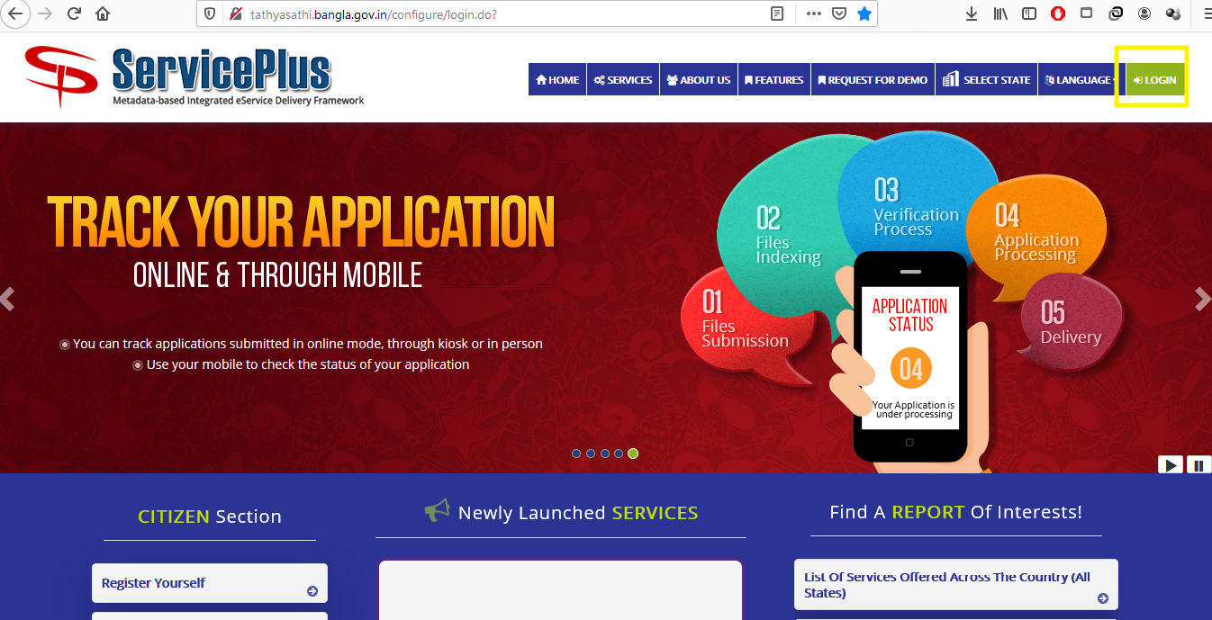
Step -2 :

Login as Applicant in the Service plus portal

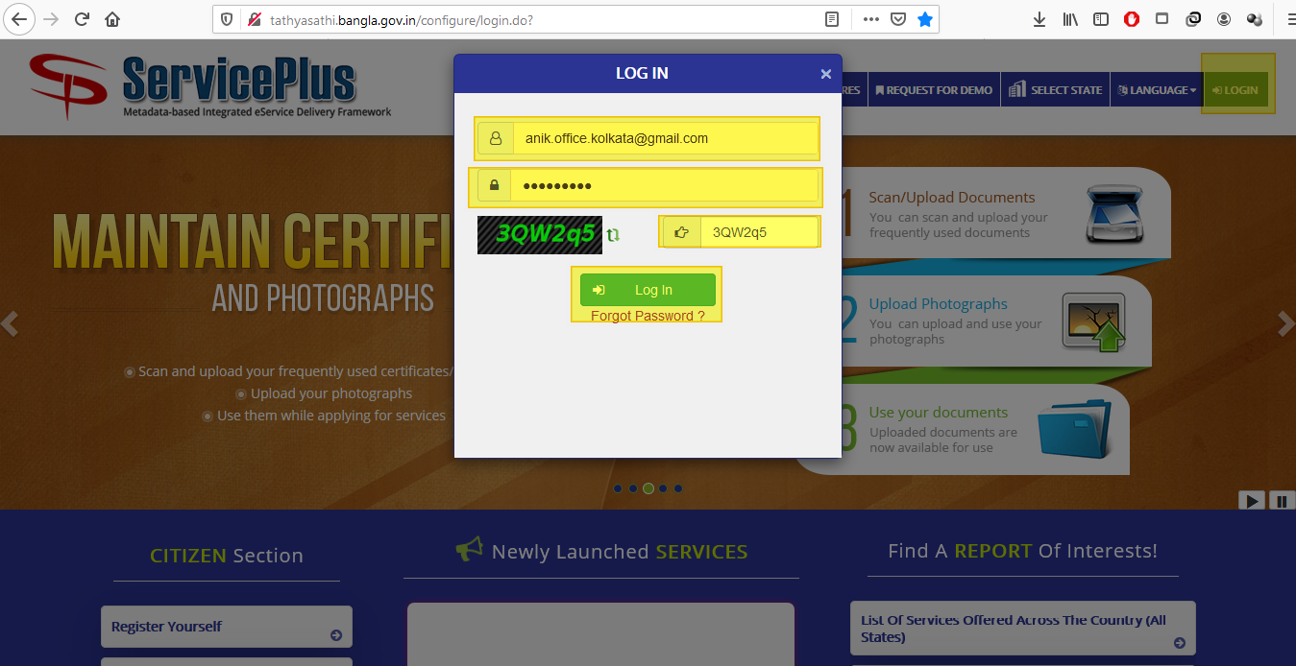

Step -3:

Now click “Apply for services” and select “View all available services”, then Select particular Service and Fill the form:

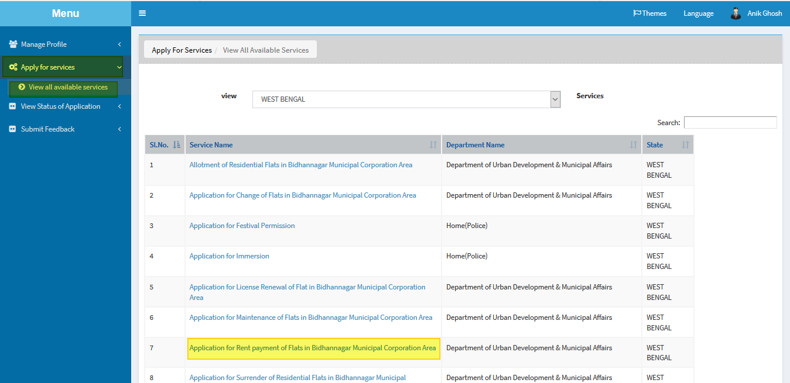
Step -4:

Fill the details “Flat No” and “License Number” and click Get Data.

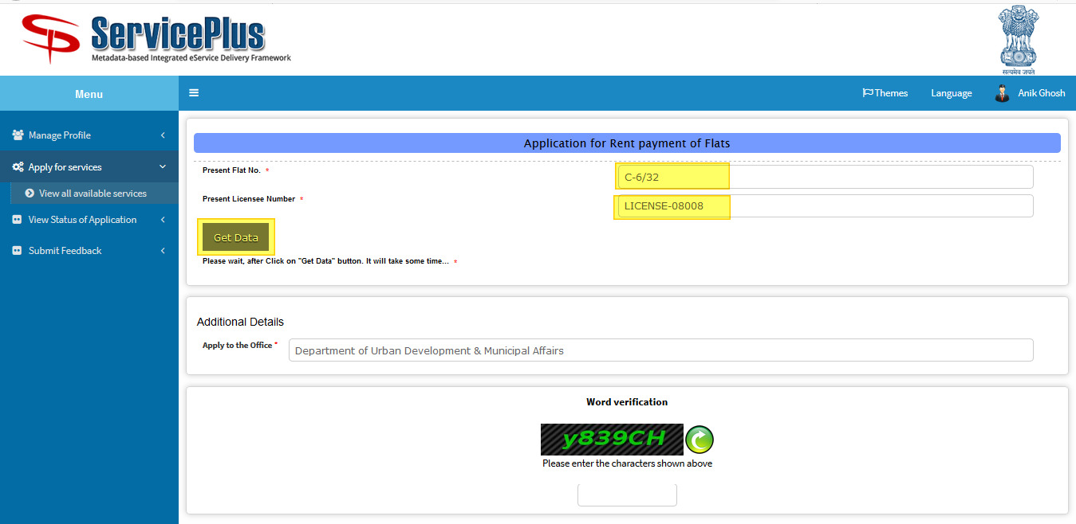

Step -5:

Fill the form with the details.
Do fill the latest payment detail with appropriate detail such as “payment plan” you can select in monthly, quarterly and half yearly.
After that submit by matching the captcha.
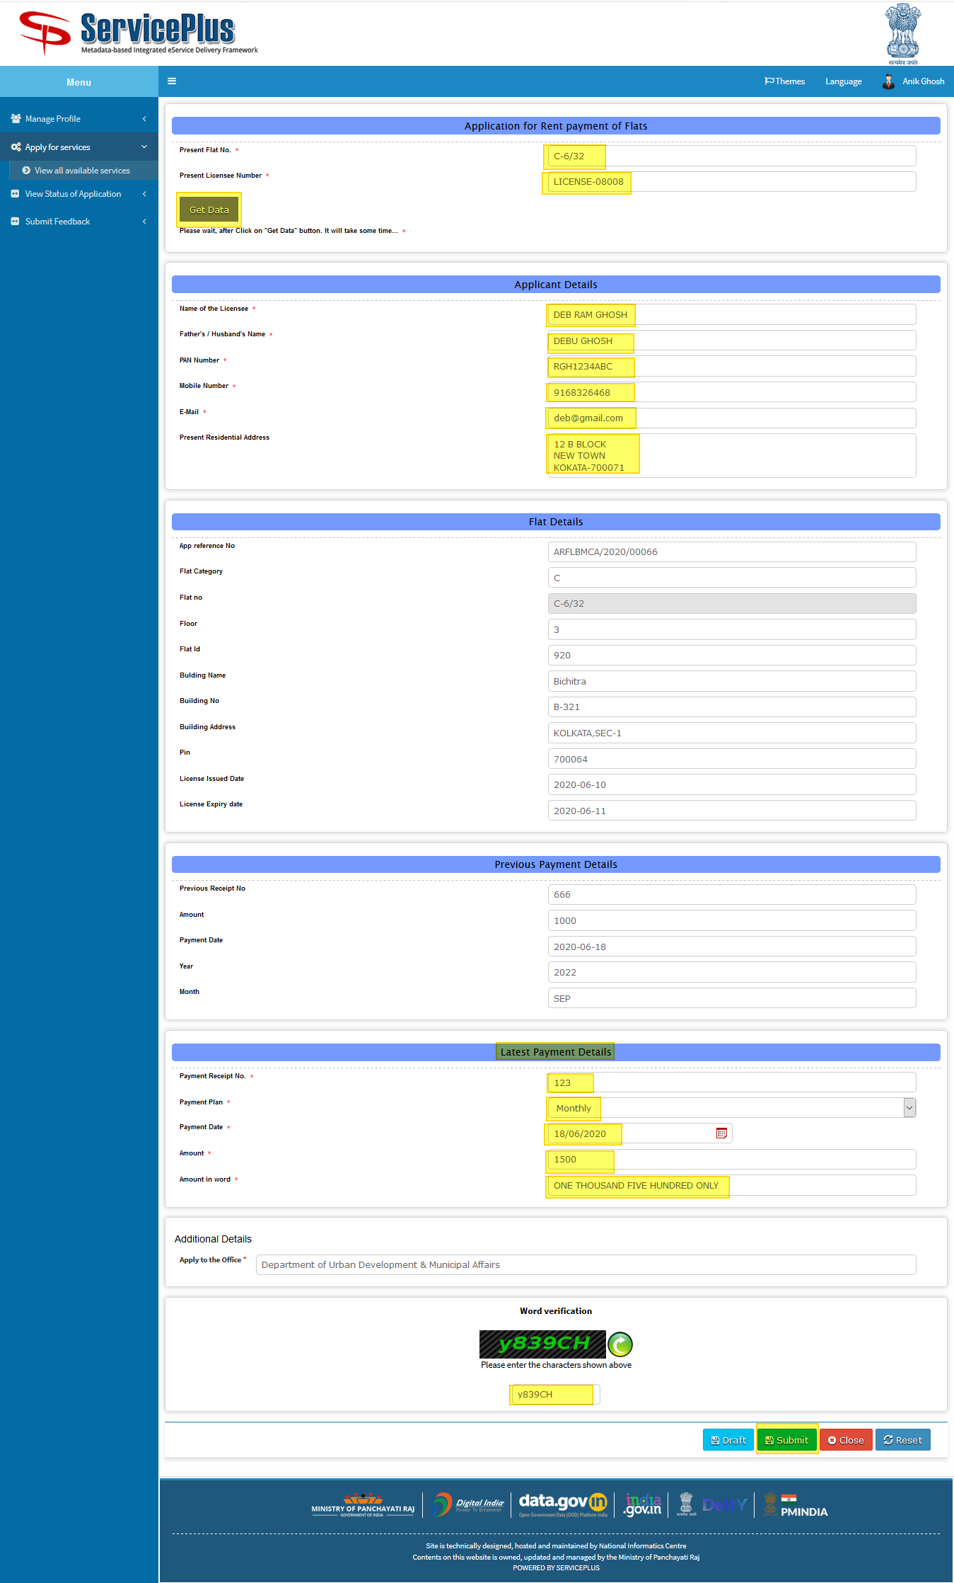
Step -6:

Now click “Attach Annexure” to attach your provided document.

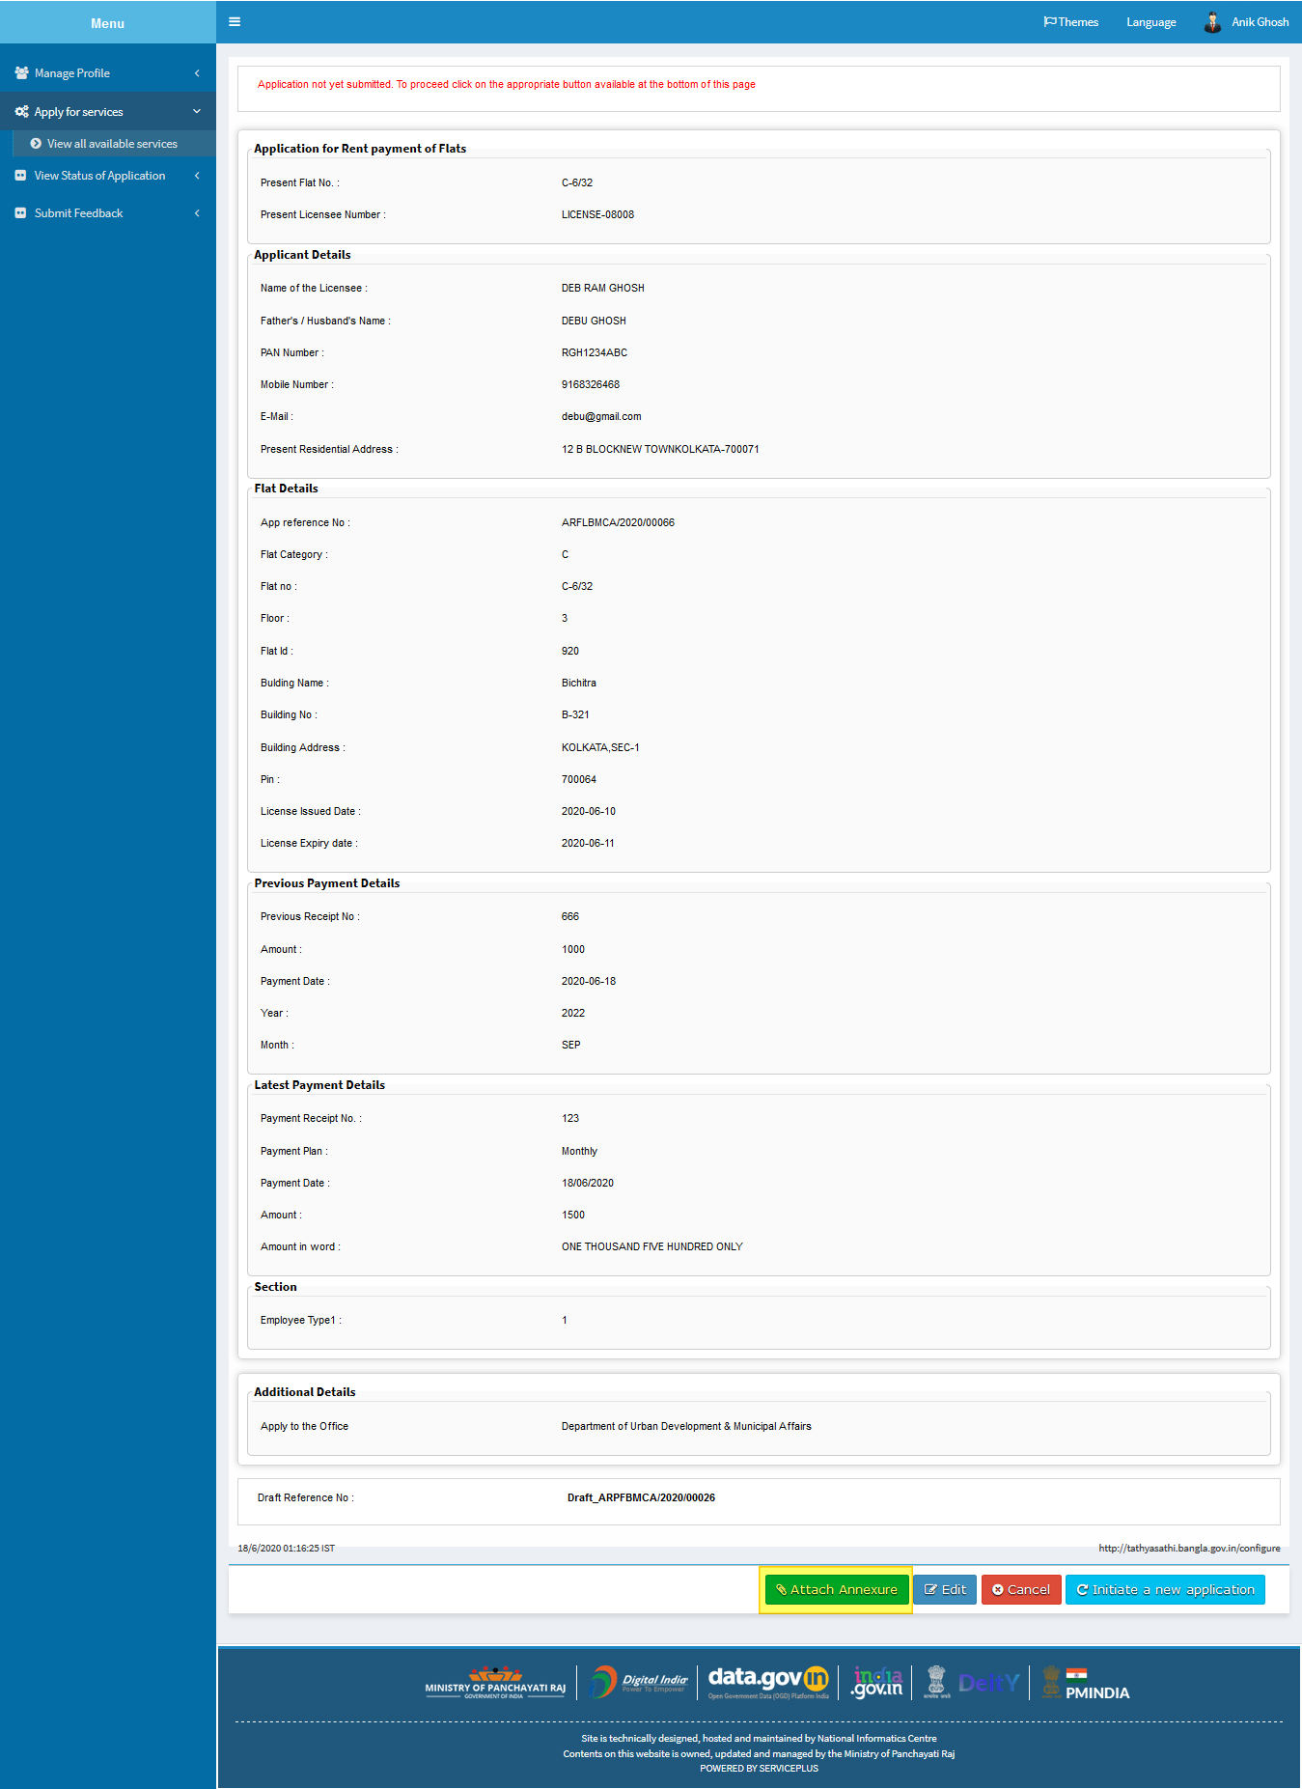
Step -7:

Now select the appropriate annexure and click on “save annexure”.

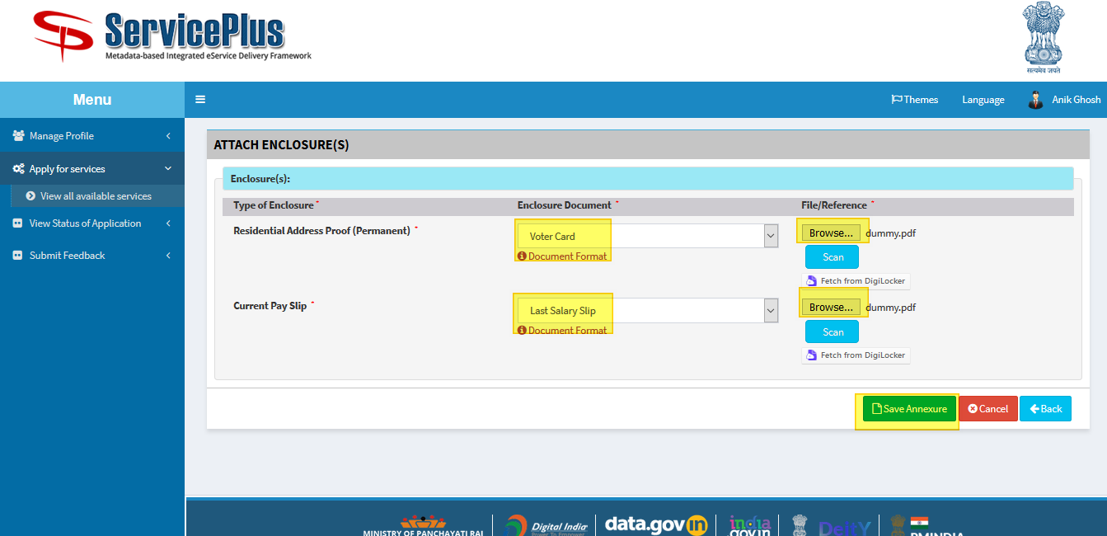

Step -8:

Now go through the form and click submit for application.

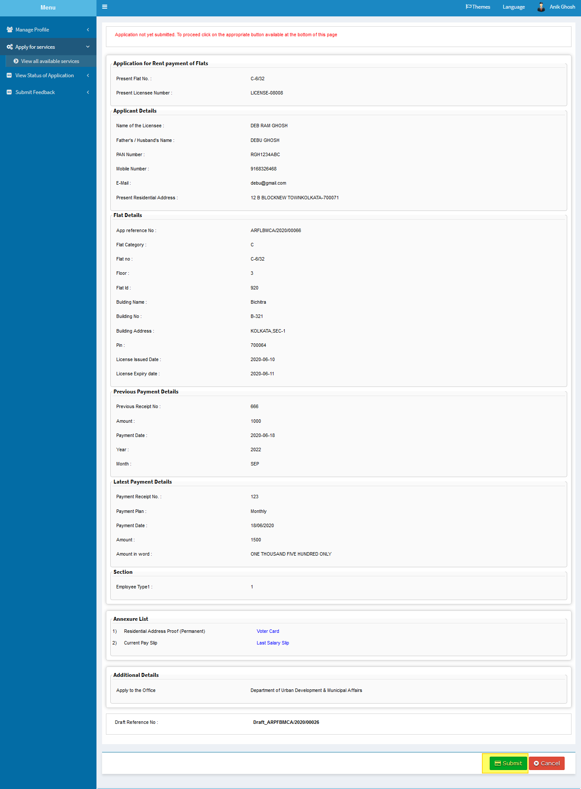
Step -9:

After Submission of form an acknowledgement slip is generated with app reference number.
Save by selecting “Export to pdf” or print it by selecting “Print”

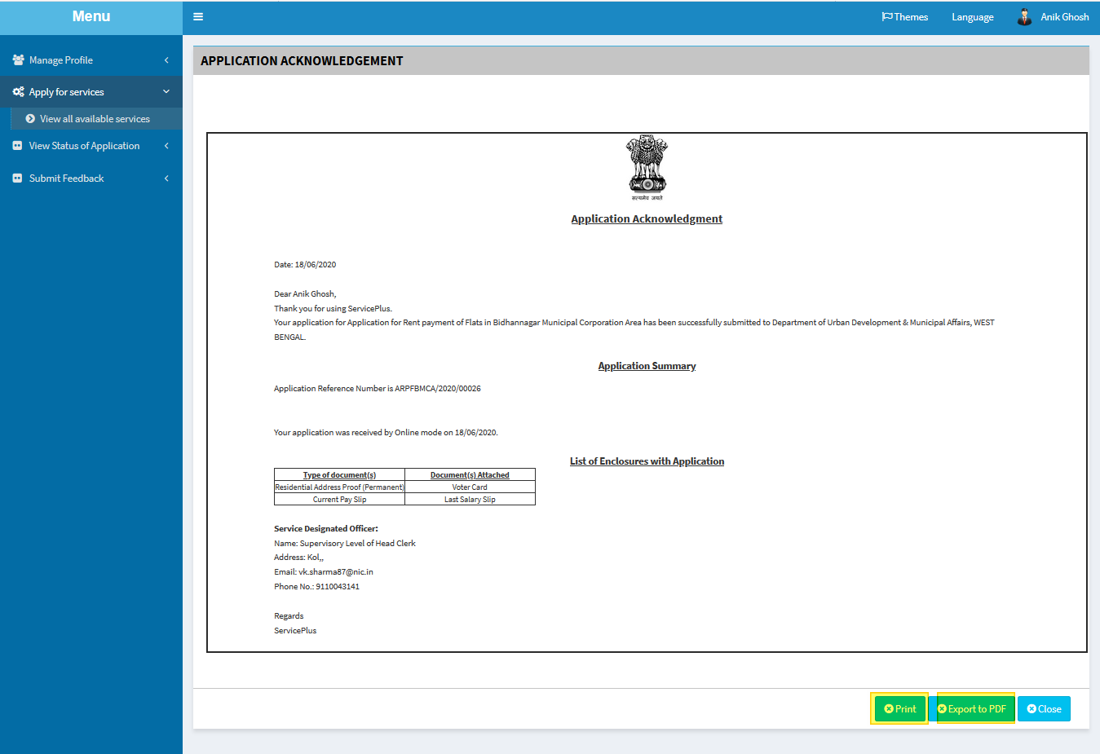

TRACKING OF APPLICATION
Step -1:

To Track the application we can select “View Status of Application” and go to “Track application status”.
Here select the appropriate date from to when and it’s optional to give “app ref no” to “get data”.

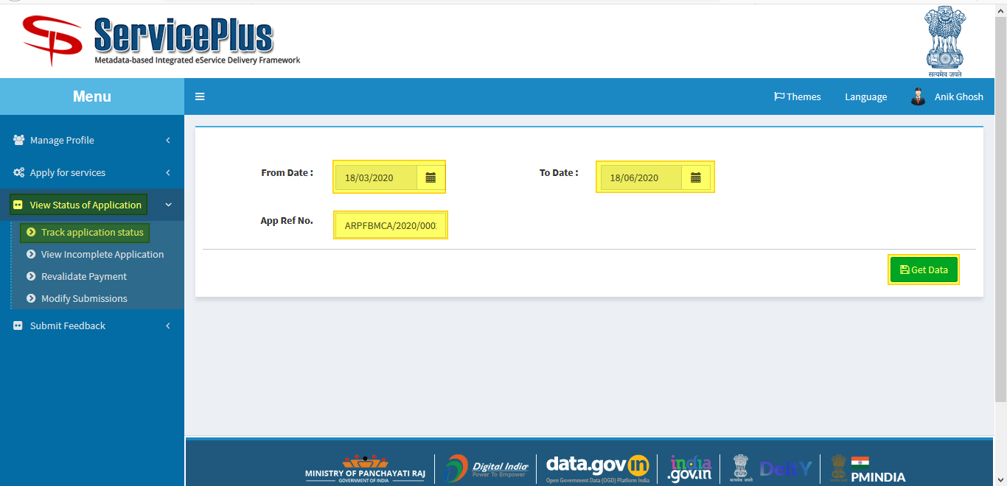
Step -2:

Now by getting the application select “current status” of the application to keep the track of status of application.

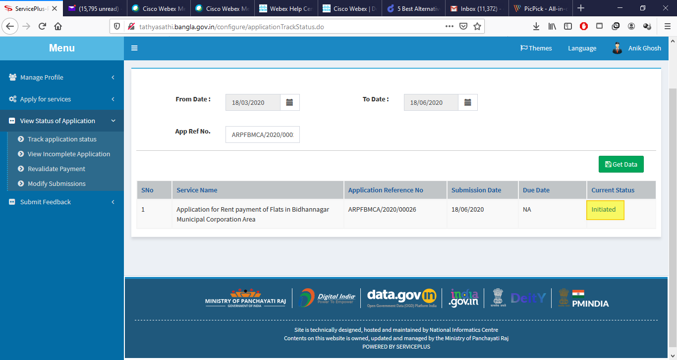
Step -3:

Here the application could be viewed and status could be seen of the application.

